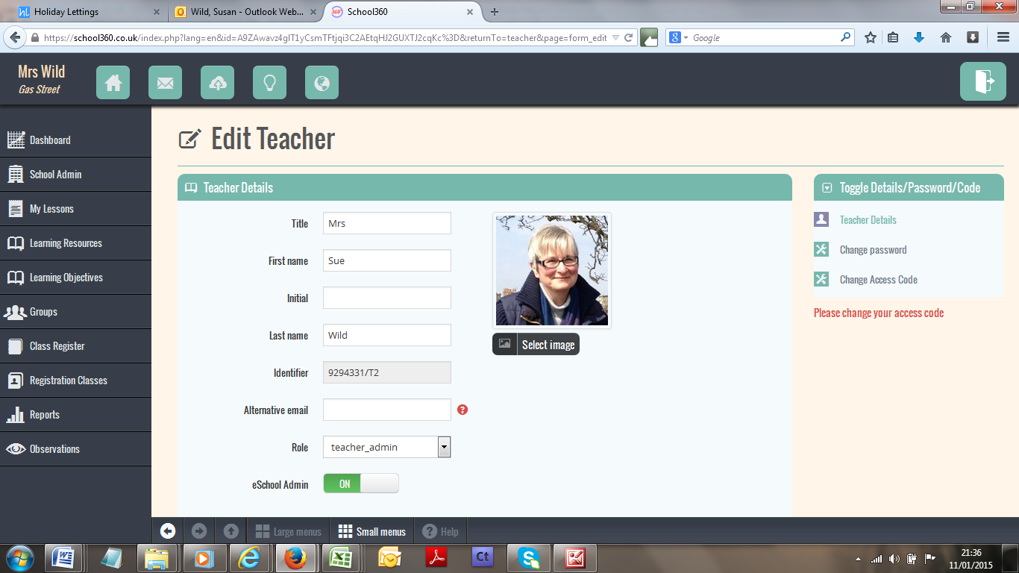
Click here to go to website

Slide to ON

