Getting Started with Podium
This brief guide will take you through the first steps towards creating a podcast with Podium.

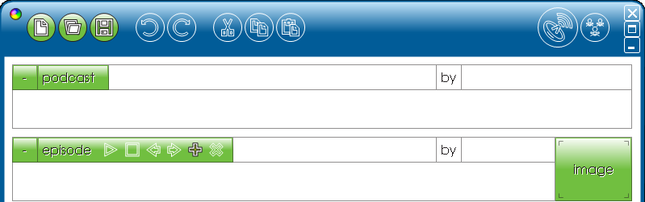
After launching Podium, the first step is to enter details for your podcast. This includes a title, name(s) of the podcast creators and the title of the first episode and creator(s) names.

At this point, it is worth saving your podcast using the small ‘floppy disk’ icon. It will be saved as ‘*.podium’ file. When your podcast is complete and saved, it is this .podium file that you will re-open to add future episodes.

The next step is to begin recording your podcast. The podcast could be made up of voice-recordings directly into podium, imported recordings from an external device, sound effects, music etc. all of this will have been planned beforehand and possibly scripted.

Track 1 is initially available. The toolbar at the top provides the tools to begin.

Program sound clips
Import sounds
Minimise

Record
Add more tracks
Zoom into sound file

Click the ‘record’ button and podium will count you in. The pause and stop buttons will be visible while you are recording your sound.




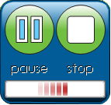

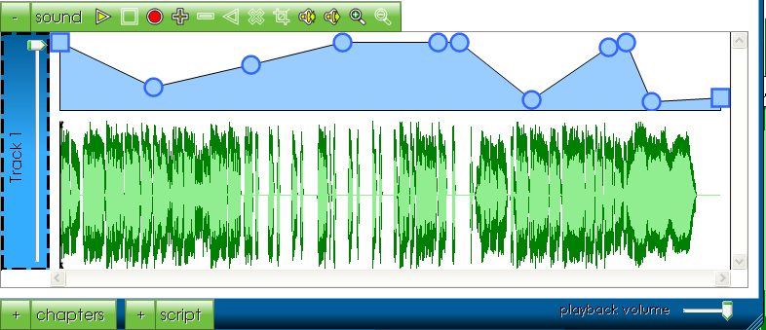
After stopping the recording, the waveform will appear. This can be edited in a variety of ways. Using ‘volume control points’, you can lower the sound at those points in the recording by dragging the circles down. You can click on the volume line to create additional Volume control points.
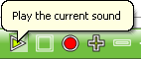
The play button will play-back your sound recording. Your first podcast has now been recorded.

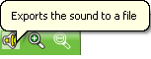
As a basic sound file, this podcast can be exported in mp3 format. This can be listened to independently or given to other listeners for example via a web page download or sent via e-mail.

However, as a podcast, the basic principle is that it is the first of a number of recordings in this podcast. Therefore, it has to be broadcast so that users can subscribe to it.

Once a recording has been made, the ‘publish’ button becomes live shown by its orange colouring. Click on this to upload the podcast to your school’s podium area.

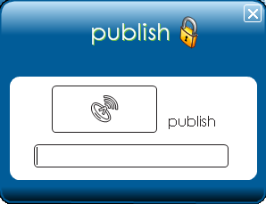
If your security is switched on (recommended) so that only authorised people can upload a podcast, you will be asked to enter a password. Podium will then connect and then upload the podcast.

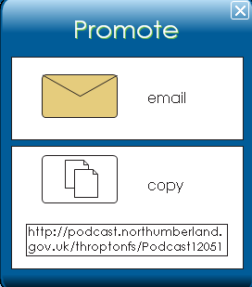
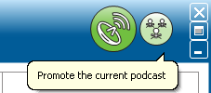
The final step is to publicise the podcast. This is done by selecting the ‘Promote Podcast’ button providing you with an option to e-mail the link or to copy the link and embed it into NorTLE or a web page.

A listener can then subscribe by pasting the link into their chosen aggregator such as iTunes, Juice or Internet Explorer (version 7 or above). They will be presented with a page allowing them to download the mp3 file or subscribe so that they receive future podcasts.
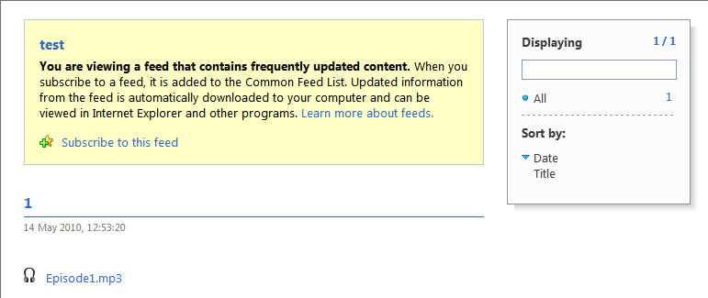

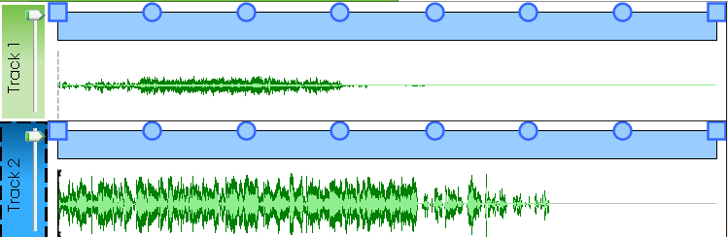

Podium also allows multi-tracking, scripting and the creation of chapters within podcasts.

