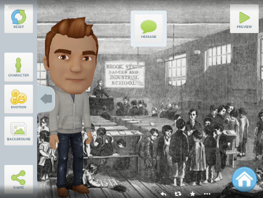Tellagami

Customise a character and background then record your own voice to create a fantastic presentations.

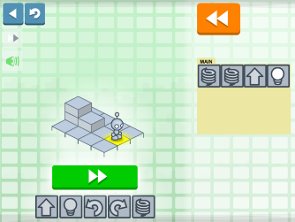

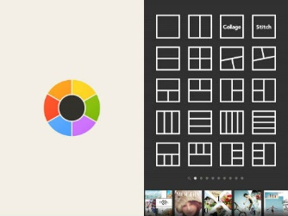Lightbot Jr Coding Puzzles

A lovely little app designed specifically for 4 – 8 year olds. A great introduction to basic concepts such as debugging, procedures and loops.

Quick Math Jr

This app is great fun for children aged around 3 – 7. Questions based around addition, subtraction, counting and place value are adjusted to ensure each child plays at the appropriate level.

Moldiv

Combine and edit multiple photos to create a collage based around your current topic of work. Add captions to create a magazine cover, poster or blog.

Videolicious

This app allows you to combine videos, photos and music. Perfect for creating professional looking new reports, advertisements and interviews.